Aim: To familiarize oneself with the SageMaker environment and create a notebook instance for developing and running ML code.
Theory:
- Amazon SageMaker Notebook: A managed Jupyter notebook instance that provides a powerful, integrated environment for data exploration, analysis, and model training. It comes pre-packaged with common data science libraries and AWS SDKs.
- Amazon S3 (Simple Storage Service): A scalable object storage service used here to store the training dataset. SageMaker training jobs are optimized to read data efficiently from S3.
- Linear Regression: A statistical method for modeling the relationship between a dependent variable (target) and an independent variable (feature) by fitting a straight line to the data.
- Data Visualization: The process of creating graphical representations of data. In this lab, we will use a scatter plot for our data points and a line plot for our model's predictions to visually assess how well the model fits the data.
- Mean Squared Error (MSE): A common metric used to measure the performance of a regression model. It calculates the average of the squared differences between the actual and predicted values, providing a measure of the model's error. A lower MSE indicates a better fit. Procedure:
Procedure:
Step 1: In the AWS Management Console, search for SageMaker and Select Amazon SageMaker from the results to open the service dashboard.
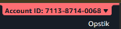
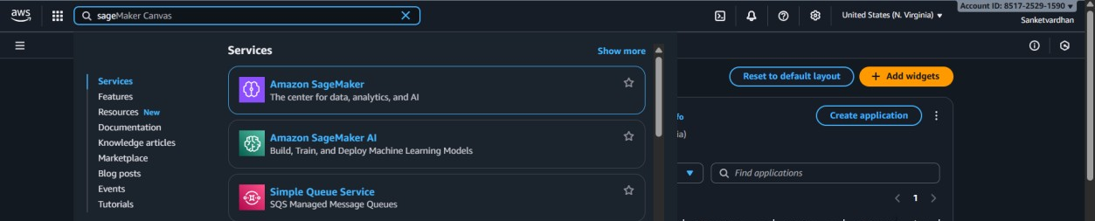

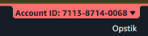
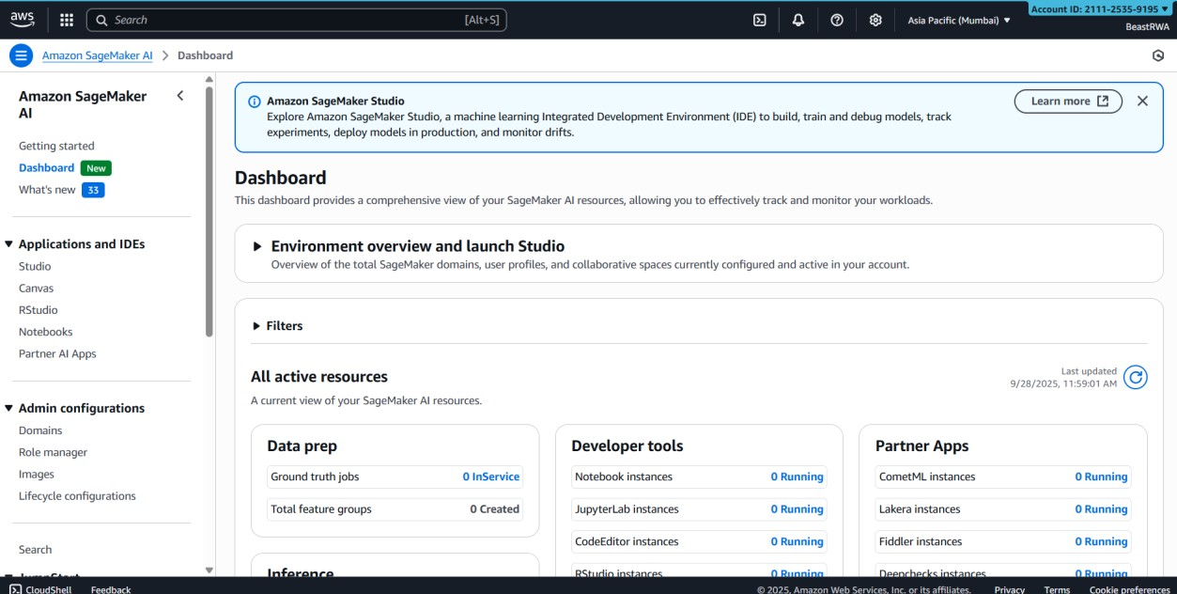
Step 2: From the Sidebar select Nodebook

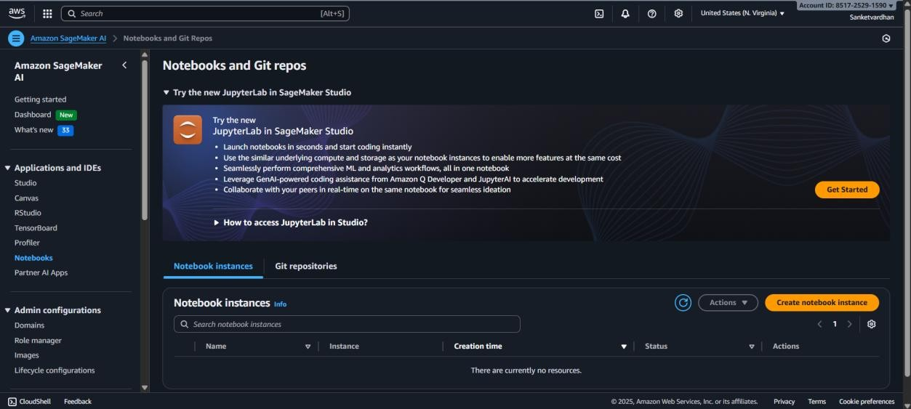
Step 3: Click ok the Create notebook instance

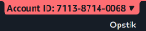
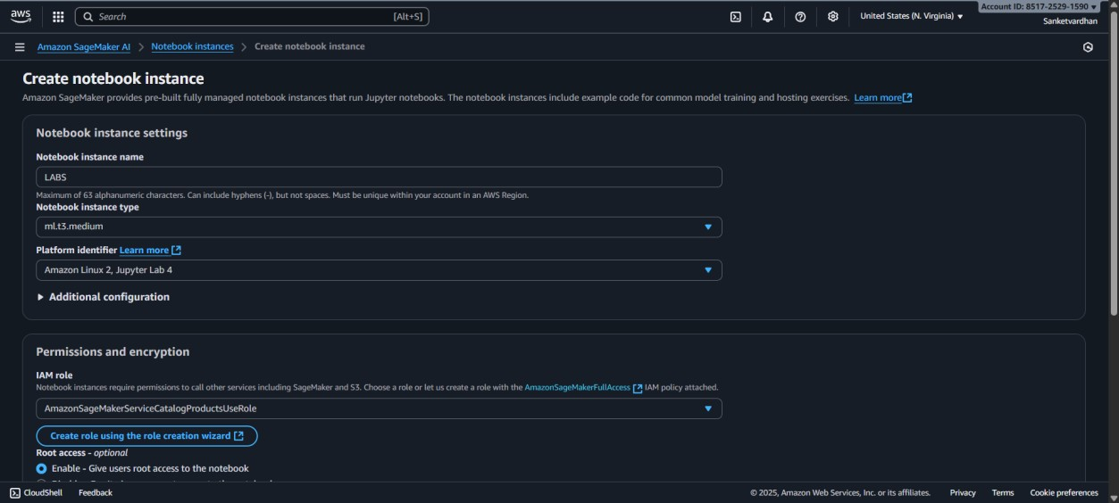
Step 4: Give the Notebook instance name

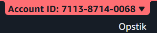
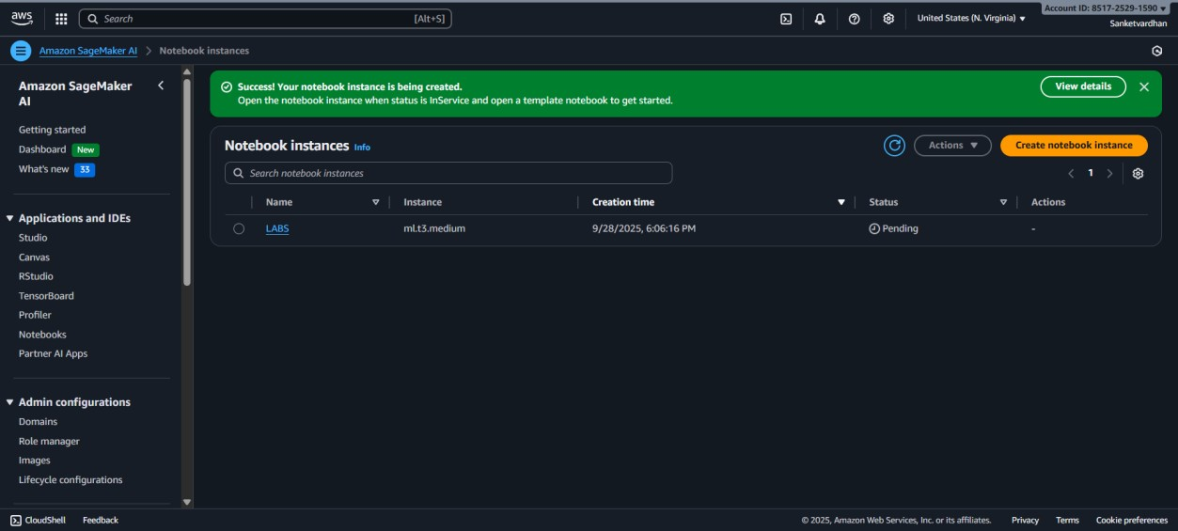
Step 5: Click on Create notebook instance at the bottom of the page

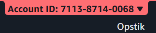
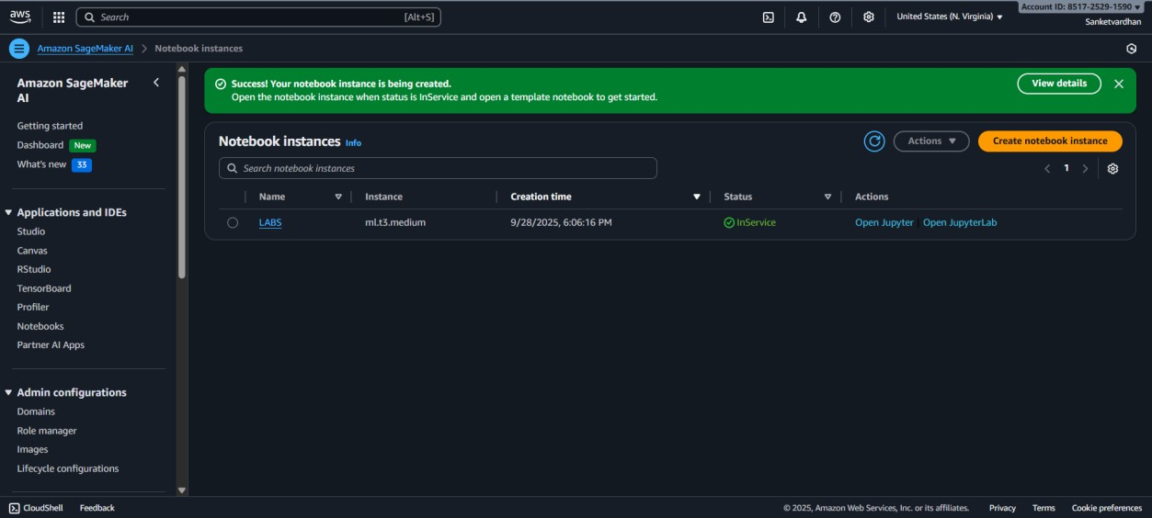
Step 6: Wait for the Notebook Status to be turned to InService

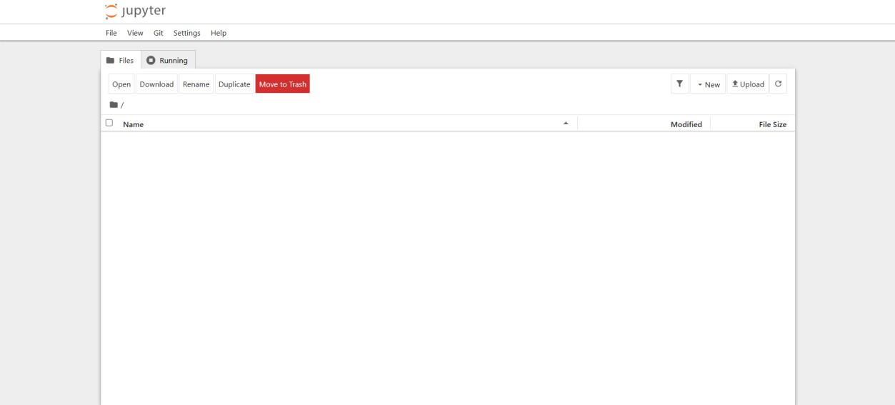
Step 7: Click on “Open Jupyter” to open the notebook in the web

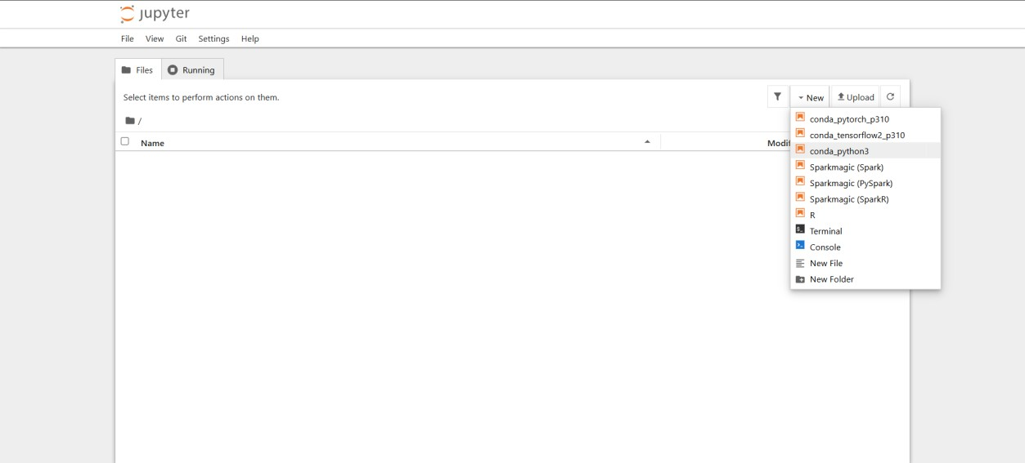
Step 8: Click on the New Dropdown and select the “conda_python3” notebook

Step 9: The notebook is created, and we can enter code to run it.
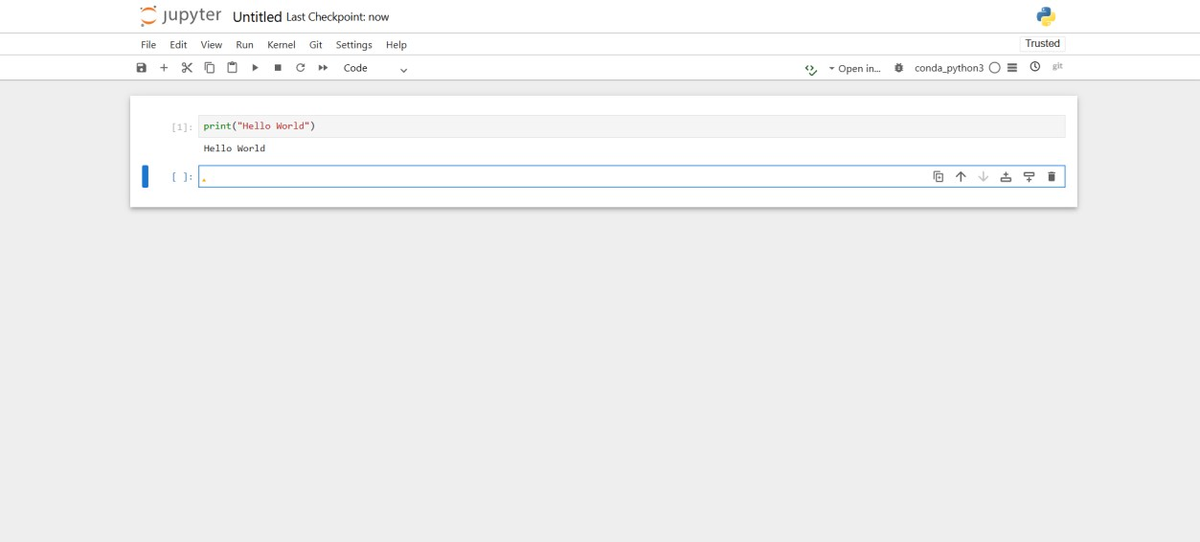

Conclusion: This lab provided a successful, hands-on introduction to Amazon SageMaker by guiding us through the creation and launch of a Notebook Instance. We experienced how these instances serve as a fully managed and pre-configured development environment, which eliminates infrastructure overhead and allows an immediate focus on machine learning code. By verifying the instance's access to its IAM role and default S3 bucket, we confirmed its seamless integration within the wider AWS ecosystem. Critically, this exercise highlighted the importance of diligent resource management—stopping and deleting instances to control costs—a fundamental best practice that prepares us to now leverage this powerful tool for the complete ML lifecycle, from data preparation to model deployment.

